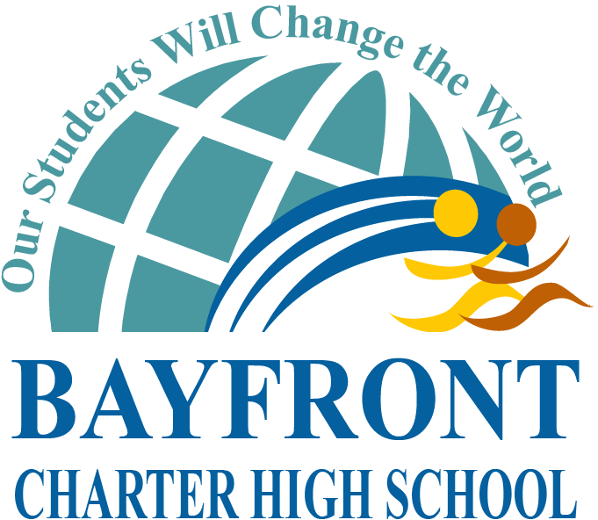

BAYFRONT CHARTER HIGH SCHOOL
LEADERSHIP COUNCIL MINUTES
10-22-14

Leadership Council Members: Ryan Santos, Elisa Aguirre, Cara Hetrick, Linda Libby, Alexis Del Castillo, Richard Ma, Armando Vidales, Kristopher Cawood, Athena Wilker, Johanna Mejia
LC Staff: Kevin Riley
Not Present:
Presented By | AGENDA ITEM | ACTION | BACKGROUND | Person Responsible | Next Steps
MINUTE AGENDA ITEMS
Michelle Saflar | Service Learning Program | Michelle Saflar proposed Service Learning Program (SLP) to Leadership Council. Purpose, Design, and Scope of Program was discussed. Teachers provided input with regards to how SLP could be implemented during advisory periods. Plan for SLP implementation over the course of four years was also discussed. LC discussed importance of obtaining feedback from Community Council prior rolling out plan next semester.  Information only. | Need for Community Service Program | Dr. Riley & Michelle Saflar | Present to Bayfront’s Community Council to obtain
Dr. Riley | Purchase of 10 additional MacBook Air | Dr. Riley proposed the purchase of an additional 10 MacBook Airs. Currently 8 students do not have an assigned laptop for the 1:1 Laptop Program. LC approved purchase of additional laptops so that these students have access to online curriculum.  LC Approved. | Bayfront has 1:1 Laptop Program where every student is assigned a MacBook Air. Enrollment has increased since initial purchase and students use laptops to access curriculum. | Dr. Riley  & Elisa Aguirre | Submit order through CVESD.
Dr. Santos | Fall Finals Schedule | Dr. Santos presented timeline for Fall Finals week (see attached). LC approved schedule and set deadline for all missing, incomplete, pending class work, homework and projects to be submitted (End of School Day – 12/12). Team began to discuss policy for students with Incompletes.  Information only. |  | Dr. Santos | Send information out part-time staff, parents, and students
Roundtable:
• Volleyball schedule game schedule for remainder of season shared.
•

